PS10 - Answer Sheet

Assignment: | PS 09
Name: | Ethan Hotson, ehotson@purdue.edu
Team-ID | 009-01
Contributor(s): | Coleman Jennewein , cjennewe@purdue.edu

Airspeed

Paired Flowchart

Individual Programming

Paired Partner
Each member of the pair will submit their own answer sheet. List your paired partner here.
Flowchart Partner: | Coleman Jennewein , cjennewe@purdue.edu

High-Level Flowchart
Examine this high-level flowchart.

You need to create flowchart sections to do the following:
- Perform any loop initialization tasks and then calculate the atmospheric pressure and temperatures for the atmospheric model
- Perform any loop initialization tasks and then calculate the dynamic pressure and speed of sound vectors for the experimental altitudes

Atmospheric Pressure and Temperature Flowchart
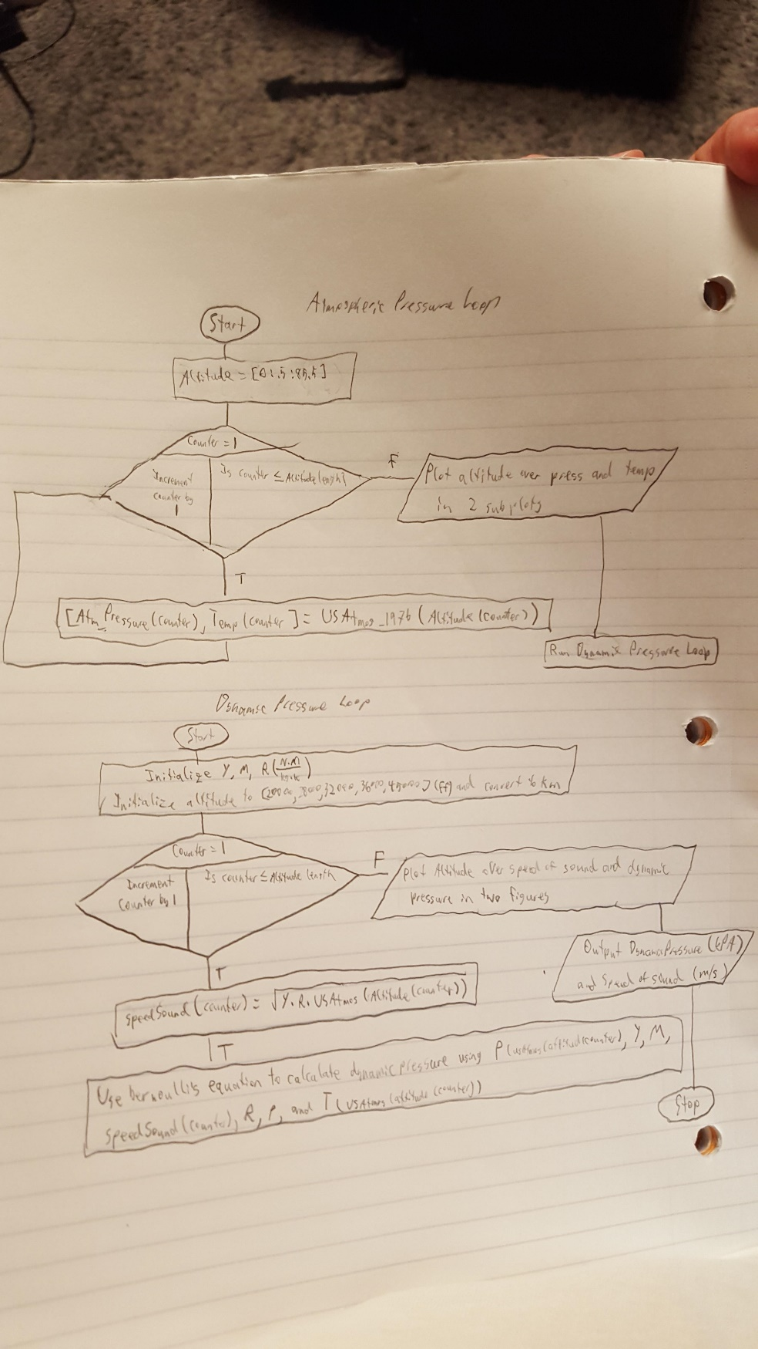

Dynamic Pressure and Speed of Sound Flowchart
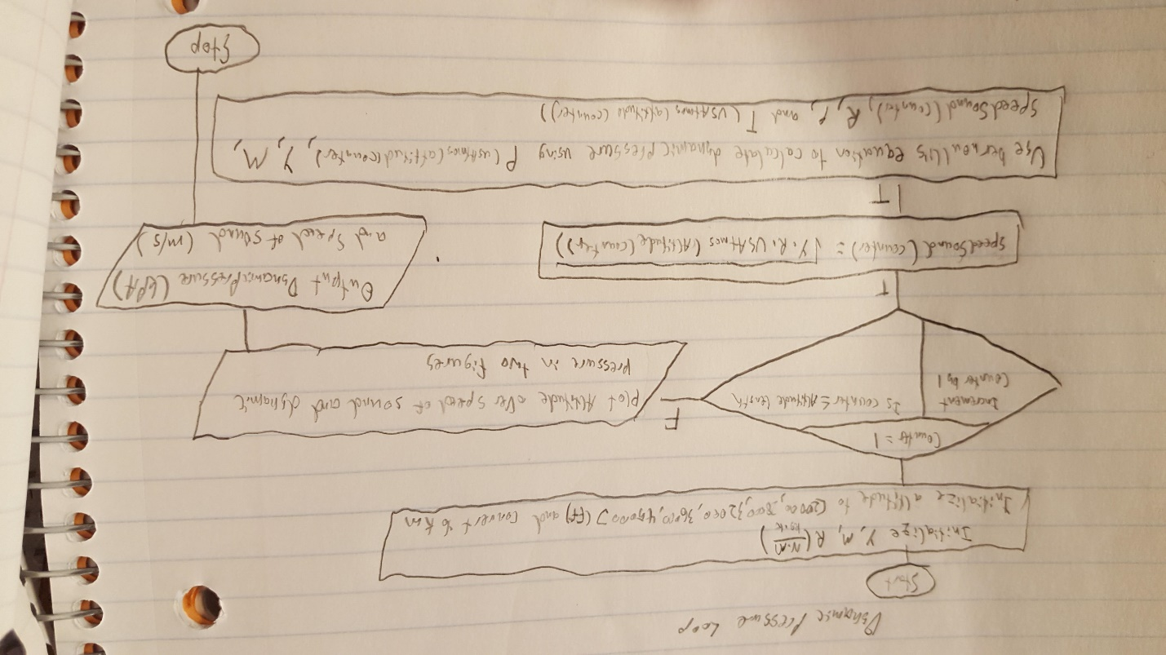

Variable Tracking Table – by hand
Complete this tracking table, by hand, for the dynamic pressure and speed of sound flowchart section you created earlier. Add rows as necessary. Use USAtmos_1976.p to calculate the required atmospheric temperature and pressure necessary to complete the calculations. Complete this table using the vector of altitudes 22,000 ft, 28,000 ft, 32,000 ft, 36,000 ft, and 45,000 ft.

 | Index | Altitude (km) | Dynamic Pressure (kPa) | Speed of sound (m/s)
Initialization
Iteration 1

Infinite Fin Revisit

Paired

Paired Partner
Each member of the pair will submit their own answer sheet. List your paired partner here.
Flowchart Partner: | Coleman Jennewein , cjennewe@purdue.edu

Flowchart
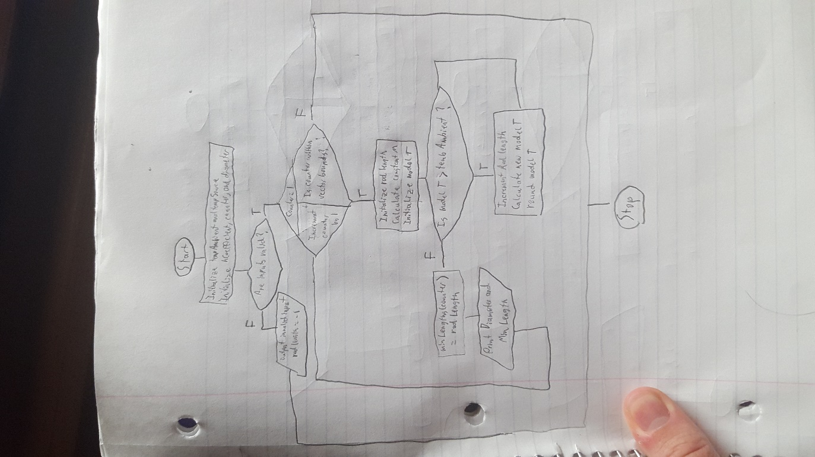

Array Sorting

Individual

Variable Tracking Table – by hand
Complete this table for input argument $A= \left[\begin{matrix}8 & -1 & 2 \\ -5 & 8 & 6\end{matrix}\right]$. Add rows as necessary.
 | Row Index | Column Index | Sorted Matrix
Initialization | 1 | 1 | [8 ,-1 ,2; -5, 8, 6]
Iteration 1 | 1 | 1 | [-5, 8, -1; 2, 8, 6]
Iteration 2 | 1 | 2 | [-5, -1, 8; 2, 8, 6]
Iteration 4 | 1 | 3 | [-5, -1, 2; 8, 8, 6]
Iteration 5 | 2 | 1 | [-5, -1, 2; 6, 8 ,8]

